Name:  Teacher: | ____________________________________  ______________________ |  | Date: _________
 | Year 9 2019  / 40  Pythagoras and Similar Triangles Test  Full working out MUST be shown to get full marks for each question.
Total Time: | 55 minutes
Weighting: | 9%
Equipment: | To be provided by the student: Pen, pencil, ruler, scientific calculator, 1 - 2-sided page of notes

Question 1 4 marks

Are the following triangles right angled? Justify your answer
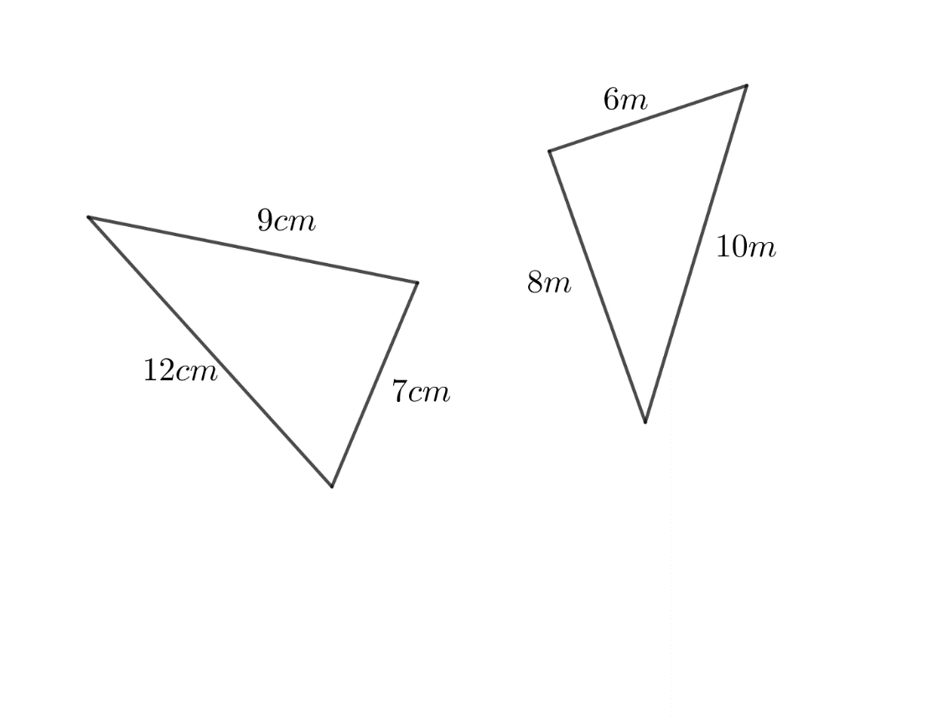  a) | 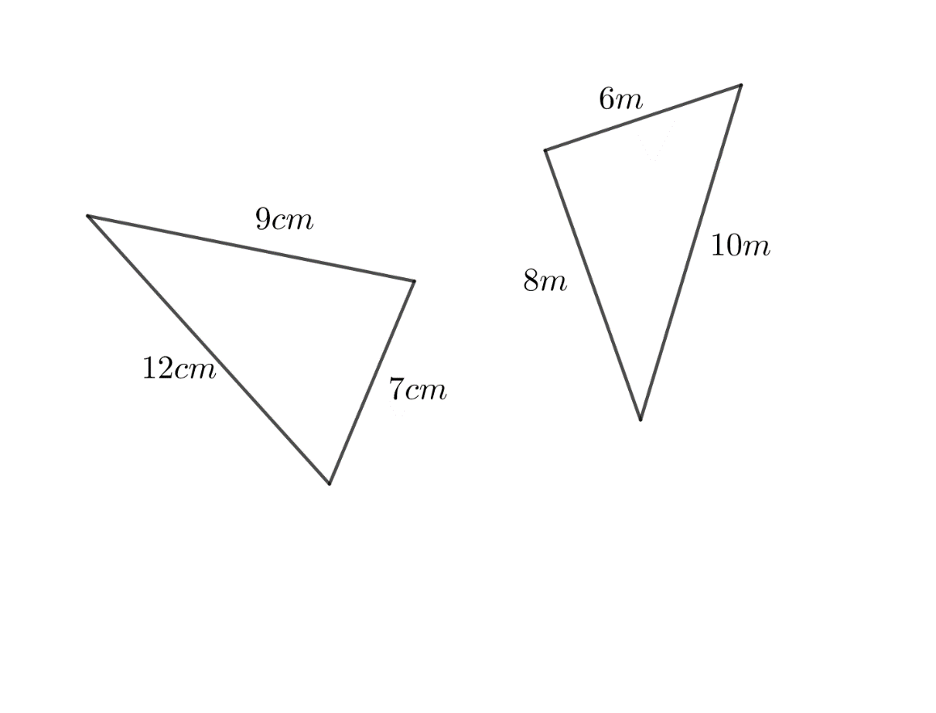  b)

Question 2 9 marks

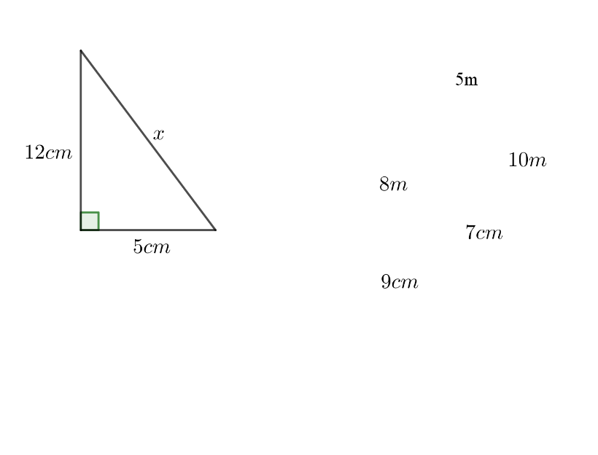
Find the value of the missing side for the following triangle.
a)

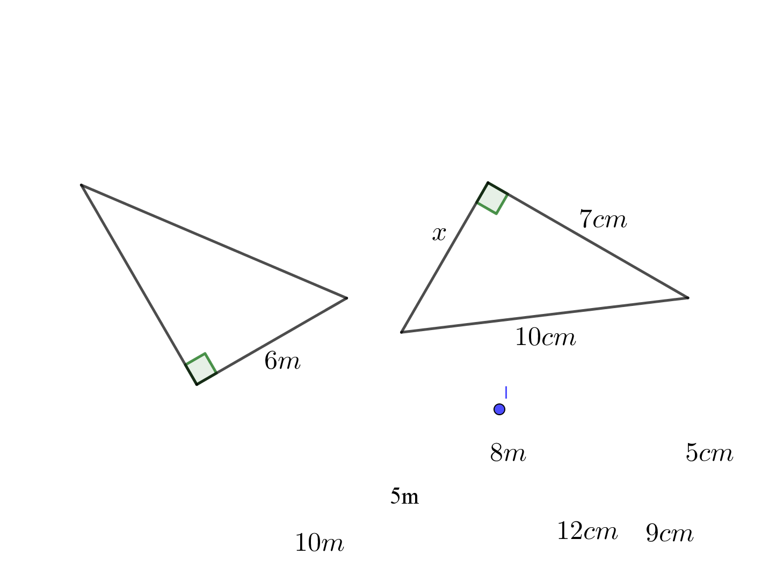
b)

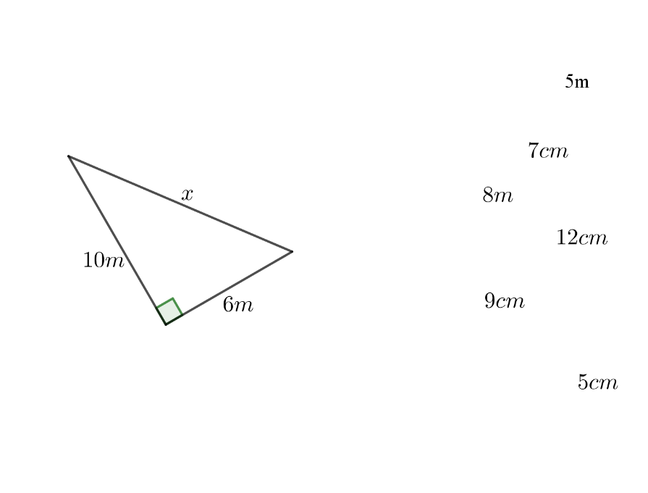
c)

Question 3 3 marks

A ladder is leaning against the wall. The top of the ladder is 4 meters high on the wall, and the bottom of the ladder is 3 meters from the wall. Draw a diagram for this and find the length of the ladder.

Question 4 4 marks
A pilot flying a plane at an altitude of 1790 m sees a mountain peak 2540 m high, 2800 m away from him in the horizontal direction. Find the direct distance between the plane and the mountain peak, correct to the nearest metre.
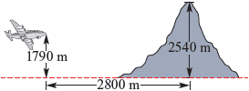

Question 5 5 marks
This pair of figures are similar.
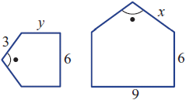

- Find a scale factor.

- Find the value of x.

- Find the value of y.

Question 6 2 marks

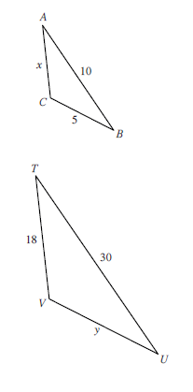

Find the unknown side for the following similar triangles:

Question 7 6 marks

Determine if the following pairs of triangles are similar, and state the similarity test that proves it.

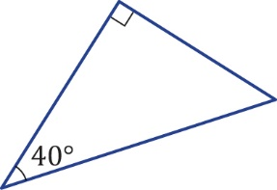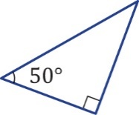

Question 8 4 marks

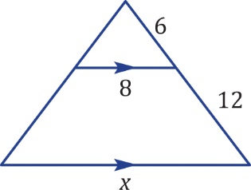

- Give a reason why the two triangles are similar.

- Find the value of x.

Question 8 3 marks

Tonya is 1.3 meters tall. She stands 7 meters in front of a tree and casts a shadow 1.8 meters long. How tall is the tree?
